SIDHANT CHAKU 22BDS0123

WEB PROGRAMMING

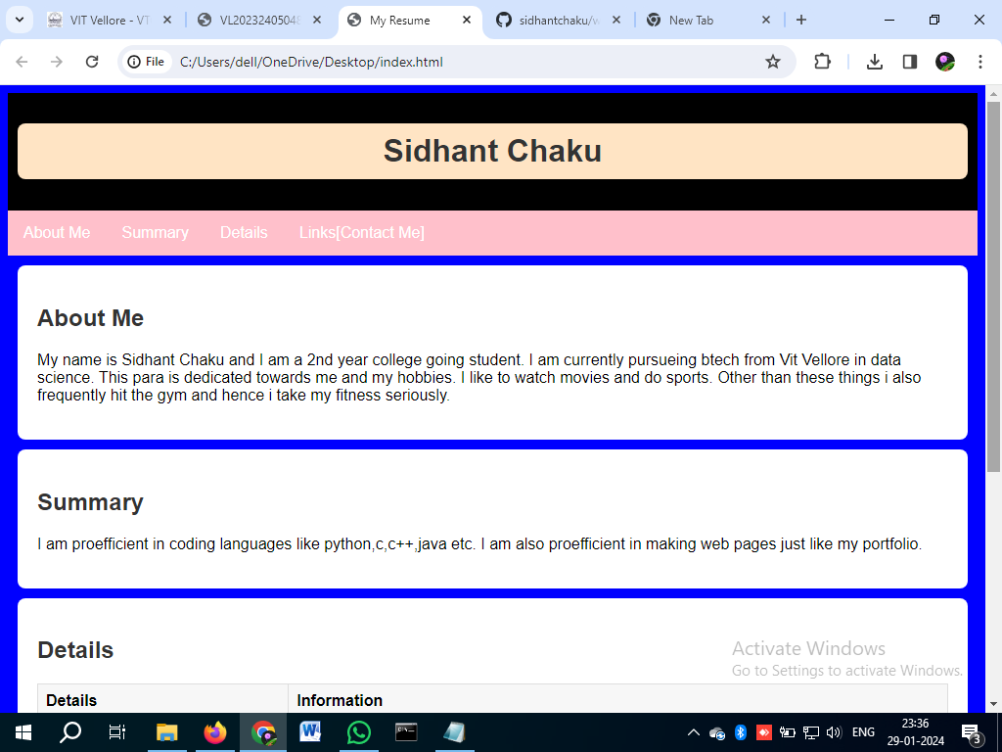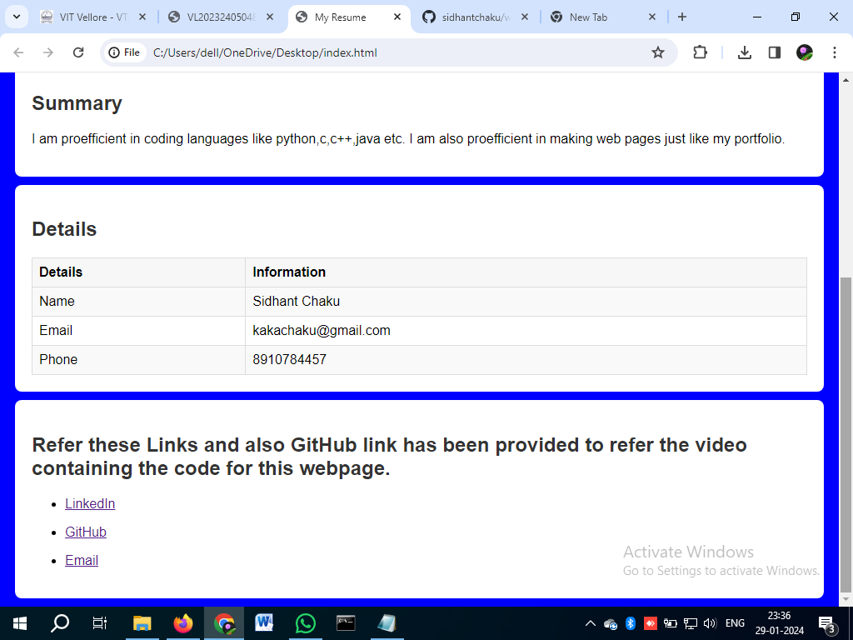

PROG CODE:

<!DOCTYPE html>

<html lang="en">

<head>

<meta charset="UTF-8">

<meta name="viewport" content="width=device-width, initial-scale=1.0">

<title>My Resume</title>

<style>

body {

font-family: red, sans-serif;

margin: 10;

padding: 10;

background-color: blue;

}

header {

background-color: black;

padding: 10px;

text-align: center;

color: white;

}

nav {

background-color: pink;

overflow: hidden;

}

nav a {

float: left;

display: block;

color: white;

text-align: center;

padding: 14px 16px;

text-decoration: none;

}

nav a:hover {

background-color: #555;

}

section {

padding: 20px;

background-color: white;

margin: 10px;

border-radius: 8px;

}

h1, h2, h3 {

color: #333;

}

table {

width: 100%;

border-collapse: collapse;

margin-top: 20px;

}

th, td {

border: 1px solid #ddd;

padding: 8px;

text-align: left;

}

th {

background-color: #f7f7f7;

}

tr:nth-child(even) {

background-color: #f9f9f9;

}

</style>

</head>

<body>

<header>

<h1 style="background-color: bisque; padding: 10px; border-radius: 8px;">Sidhant Chaku</h1>

</header>

<nav>

<a href="#about">About Me</a>

<a href="#summary">Summary</a>

<a href="#details">Details</a>

<a href="#links">Links[Contact Me]</a>

</nav>

<section id="about">

<Body background=”download.jpg“>

<h2>About Me</h2>

<p>My name is Sidhant Chaku and I am a 2nd year college going student. I am currently pursueing btech from

Vit Vellore in data science. This para is dedicated towards me and my hobbies. I like to watch movies and do sports.

Other than these things i also frequently hit the gym and hence i take my fitness seriously.</p>

</section>

<section id="summary">

<h2>Summary</h2>

<p> I am proefficient in coding languages like python,c,c++,java etc. I am also proefficient in making web pages

just like my portfolio.</p>

</section>

<section id="details">

<h2>Details</h2>

<table>

<tr>

<th>Details</th>

<th>Information</th>

</tr>

<tr>

<td>Name</td>

<td>Sidhant Chaku</td>

</tr>

<tr>

<td>Email</td>

<td>kakachaku@gmail.com</td>

</tr>

<tr>

<td>Phone</td>

<td>8910784457</td>

</tr>

</table>

</section>

<section id="links">

<h2> Refer these Links and also GitHub link has been provided to refer the video containing the code for this webpage.</h2>

<ul>

<li><a href="https://www.linkedin.com/in/sidhant-chaku-6a23632aa/" target="_blank">LinkedIn</a></li>

</ul>

<ul>

<li><a href="https://github.com/sidhantchaku" target="_blank">GitHub</a></li>

</ul>

<ul>

<li><a href="https://sidchaku@gmail.com" target="_blank">Email</a></li>

</ul>

</section>

</body>

</html>

Brief Explanation of Tags Used:

• Structural Tags (html, head, body): Define the basic

structure of an HTML document.

• Metadata Tags (meta, title, link): Provide information

about the document, such as character set, viewport

settings, and linking to external stylesheets.

• Section Tags (header, nav, section): Organize content into

meaningful sections, improving readability and

maintainability.

• Heading and Paragraph Tags (h1, h2, p): Define headings

and paragraphs to structure content and make it more

readable.

• Table Tags (table, tr, th, td): Organize data into a table

structure.

• List Tags (ul, li): Create lists for better organization.

• Image Tag (img): Embeds images into the document.

• Link Tag (a): Creates hyperlinks to navigate within the

website or link to external resources.